Letter of Introduction
Dear Sir,
As a pioneer in automation technology, NIHVA is one of the leading Supplier & solution providers in Door Automation & Material Handing Equipments.
NOW!!
NIHVA is providing Fully Automation Solution at new edge.
- Automation Solution
- Robotics (Pick & Place) Line Solution
- Agricultural Automation solution
- Real time Monitoring & Control (RTMC) – Quality Vision System (QVS)
- Special Purpose Machine (SPM)

Automation Solution
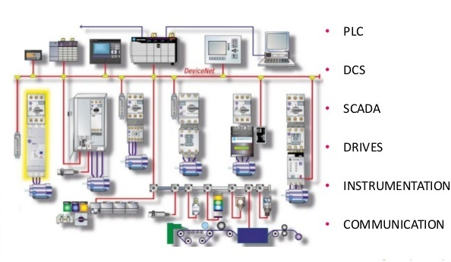

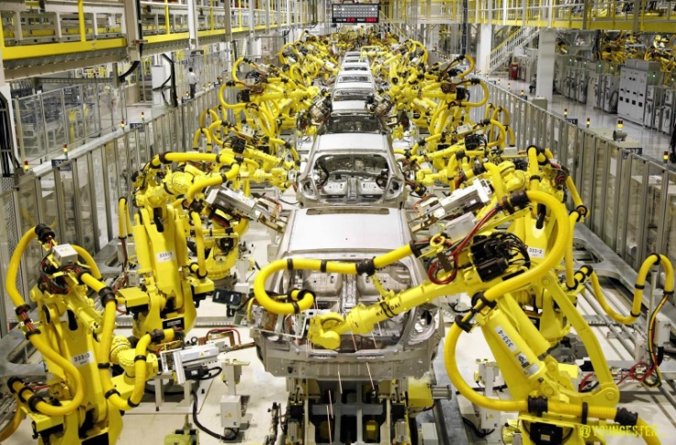
Robotics (Pick & Place) Line Solution
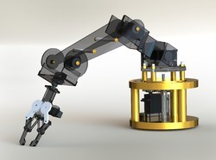

Agricultural Automation solution
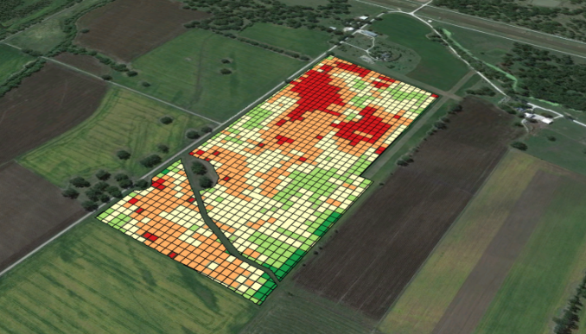
- Drones Survey
- Mapping
- Spraying
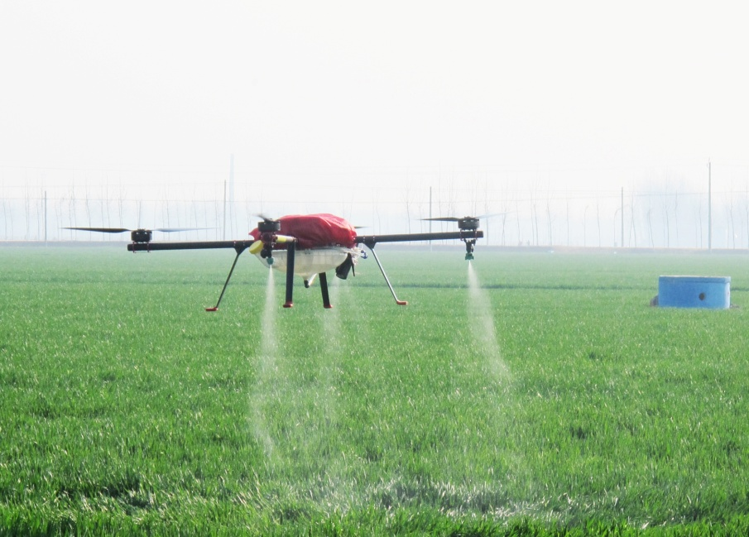
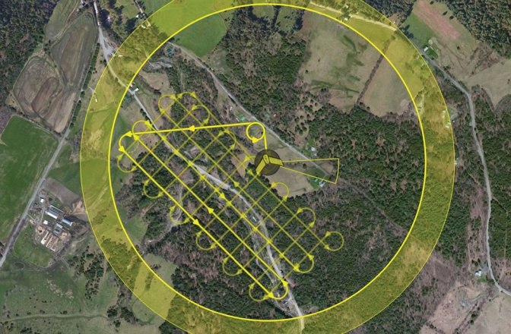

Real time Monitoring & Control (RTMC) – Quality Vision System (QVS)
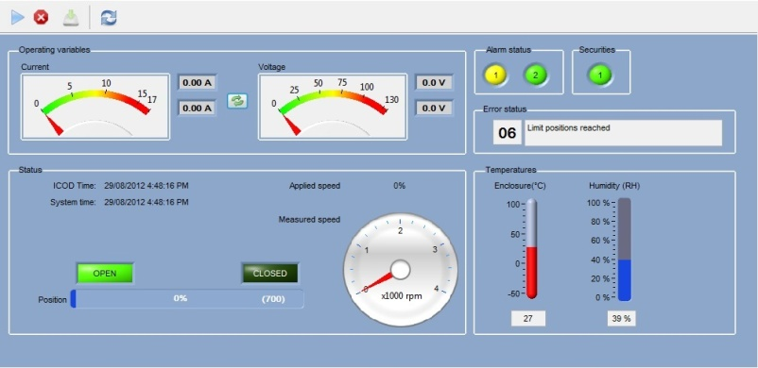
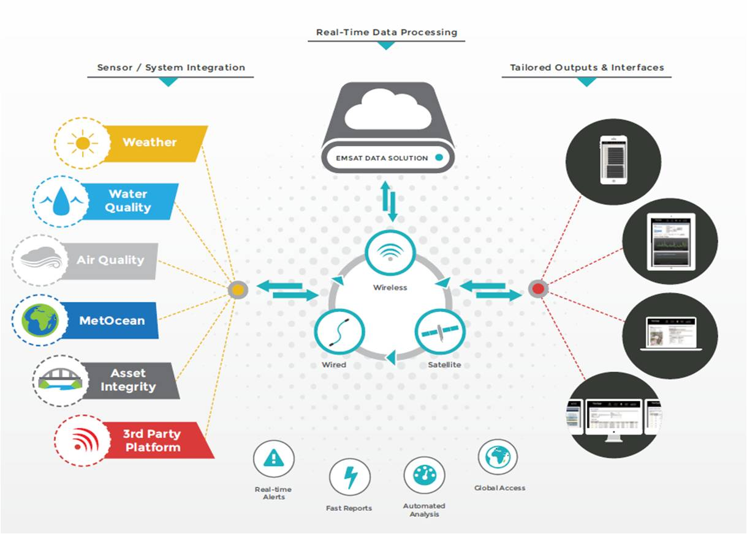

- Machine to Machine
- SCADA
- SAP
- Machine to Real Time Monitoring
Special Purpose Machine (SPM)
- Special Fixtures & mould as per user requirements for Specific part
- Integration of following to reduce errors & grow productivity capacity.
PLC
SCADA
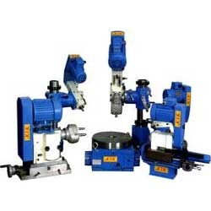
DCS
National Instruments
Hydraulics & Pneumatics
Control Cards


